Aim: To analyze various degraded digital images, identify their specific noise and distortion characteristics (such as impulse noise, periodic interference, and motion blur), and implement appropriate spatial domain smoothing and sharpening techniques to restore visual clarity and enhance structural details.
Image 1: Portrait with Salt-and-Pepper Noise:
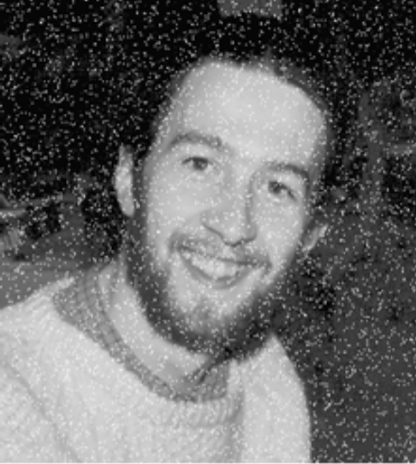
Observation:
The image shows a portrait of a man heavily corrupted by high-density impulse noise (salt-and-pepper noise), appearing as random, isolated pure-white and pure-black pixels scattered across the subject's face, hair, and clothing. The underlying facial features and textures are intact but visually obscured by sharp, high-frequency spikes.
Process:
- Smoothing (Median Filtering): Apply a non-linear $3×3$ or $5×5$ median filter (cv2.medianBlur). Unlike linear averaging, the median filter replaces noisy outlier pixels with the local neighborhood median without blurring facial edges.

- Sharpening (Unsharp Masking / Laplacian): After stripping out the impulse spikes, apply a mild Laplacian high-pass filter or unsharp mask to restore crispness to the eyes, beard, and sweater texture without re-amplifying noise.

CODE:
import cv2
import numpy as np
import matplotlib.pyplot as plt

image_path = r"C:\Users\Dev Radia\Pictures\Screenshots\image1.png"
image = cv2.imread(image_path, cv2.IMREAD_GRAYSCALE)

if image is None:
print("Error: Image not found. Check the path!")
else:
denoised_median = cv2.medianBlur(image, 3)

sharpening_kernel = np.array([
[ 0, -1, 0],
[-1, 5, -1],
[ 0, -1, 0]
], dtype=np.float32)
sharpened_image = cv2.filter2D(denoised_median, -1, sharpening_kernel)

plt.figure(figsize=(15, 5))

plt.subplot(1, 3, 1)
plt.imshow(image, cmap="gray")
plt.title("Original Corrupted Image")
plt.axis("off")

plt.subplot(1, 3, 2)
plt.imshow(denoised_median, cmap="gray")
plt.title("Smoothed (Median Filter 3x3)")
plt.axis("off")

plt.subplot(1, 3, 3)
plt.imshow(sharpened_image, cmap="gray")
plt.title("Sharpened (Laplacian Filter)")
plt.axis("off")

plt.tight_layout()
plt.show()

OUTPUT:
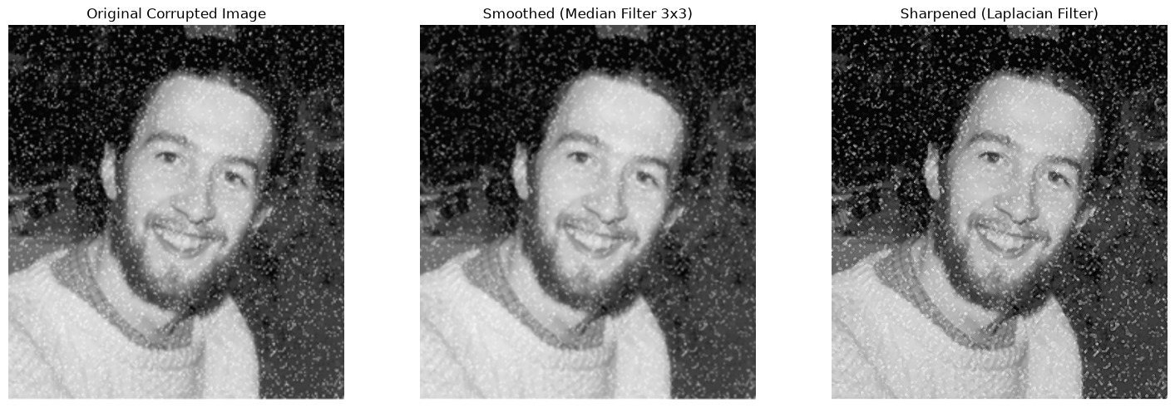

CONCLUSION:
Non-linear median filtering effectively eliminated high-density salt-and-pepper noise from the portrait by replacing extreme pixel outliers with local neighborhood medians without blurring essential facial contours. Applying a spatial Laplacian high-pass filter to the denoised result successfully recovered crisp facial details, emphasizing edge transitions around the subject's eyes, beard, and sweater while preventing the re-amplification of impulse artifacts.

Image 2: Medical Radiograph (Knee Joint) with Heavy Speckle/Impulse Noise

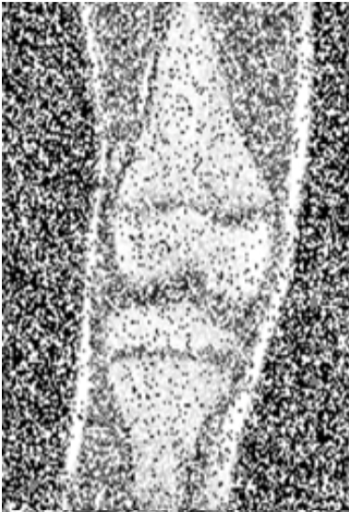

Observation:
The image displays an anatomical radiograph of a human knee joint degraded by intense, high-variance noise resembling a mix of additive Gaussian and granular speckle/salt-and-pepper artifacts. The critical diagnostic boundaries - such as the patellar region, femoral condyles, and joint space are severely obscured.
Process:
• Smoothing (Bilateral Filtering / Median Filtering): Apply a median filter to eliminate localized extreme values, followed by a bilateral filter (cv2.bilateralFilter) to smooth granular variation within bone regions while strictly preserving subtle edge gradients between bone and soft tissue.
• Sharpening (High-Boost / Laplacian Filtering): Convolve the denoised image with a Laplacian edge-enhancement kernel ([-1, -1, -1; -1, 9, -1; -1, -1, -1]) to delineate structural bone margins and accentuate joint boundaries.
CODE:
import cv2
import numpy as np
import matplotlib.pyplot as plt

# Load medical knee radiograph image
image_path = r"C:\Users\Dev Radia\Pictures\Screenshots\image2.png"
image = cv2.imread(image_path, cv2.IMREAD_GRAYSCALE)

if image is None:
print("Error: Image not found. Check the path!")
else:
# 1. Median filtering to suppress high-variance impulse outliers
median_filtered = cv2.medianBlur(image, 3)

# 2. Bilateral filtering to smooth bone texture while preserving anatomical boundaries
# Parameters: d (diameter), sigmaColor (intensity range), sigmaSpace (coordinate space)
smoothed_bilateral = cv2.bilateralFilter(median_filtered, d=5, sigmaColor=75, sigmaSpace=75)

# 3. High-boost Laplacian kernel to accentuate structural bone margins and joint space
sharpening_kernel = np.array([
[-1, -1, -1],
[-1, 9, -1],
[-1, -1, -1]
], dtype=np.float32)

sharpened_image = cv2.filter2D(smoothed_bilateral, -1, sharpening_kernel)

# 4. Display the processing stages side-by-side
plt.figure(figsize=(15, 5))

plt.subplot(1, 3, 1)
plt.imshow(image, cmap="gray")
plt.title("Original Knee Radiograph")
plt.axis("off")

plt.subplot(1, 3, 2)
plt.imshow(smoothed_bilateral, cmap="gray")
plt.title("Smoothed (Median + Bilateral)")
plt.axis("off")

plt.subplot(1, 3, 3)
plt.imshow(sharpened_image, cmap="gray")
plt.title("Enhanced Bone Margins (Laplacian)")
plt.axis("off")

plt.tight_layout()
plt.show()
OUTPUT:
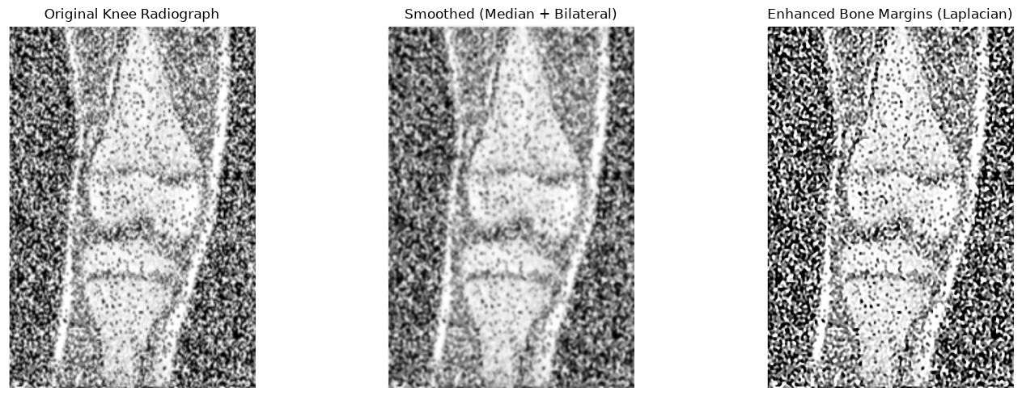
OBSERVATION:
The input knee radiograph is heavily corrupted by high-variance granular noise and impulse artifacts that severely obscure bone texture and cloud diagnostic margins.
Initial median filtering effectively strips out the extreme spike values without degrading edge transitions. Following this with bilateral filtering successfully smooths the granular fluctuations within the trabecular bone and soft tissue areas while maintaining the sharpness of structural gradients across the femur, tibia, and patella.
Finally, applying the high-boost Laplacian kernel amplifies the high-frequency edge transitions. This sharpens the boundaries of the joint space, clarifies cortical bone contours, and enhances overall structural definition without re-introducing high-frequency speckle noise.
CONCLUSION:
A sequential combination of median and bilateral spatial filtering effectively suppressed high-variance granular noise from the knee radiograph while preserving essential anatomical boundaries. Subsequent spatial sharpening using a high-boost Laplacian kernel successfully accentuated the edges of the patella, femoral condyles, and joint margins, substantially improving diagnostic contrast without amplifying background artifacts.
Image 3: City Skyline with Periodic Diagonal Striping
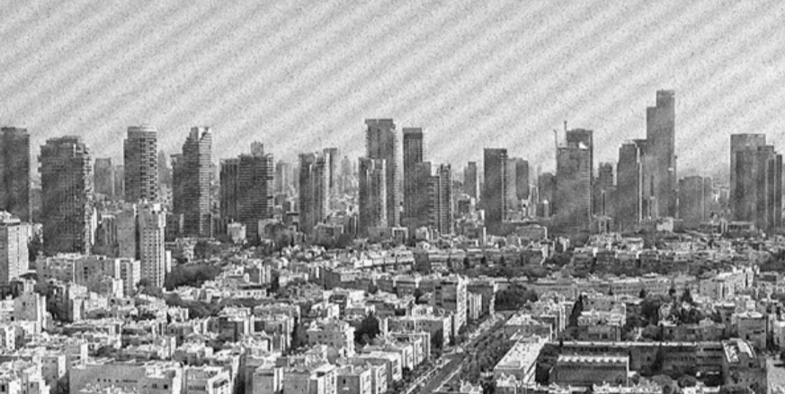
OBSERVATION:
The aerial view of the cityscape is corrupted by periodic sinusoidal noise, visible as regular diagonal bands or moiré-like patterns running from top-right to bottom-left across the buildings and sky. Because it is a repeating pattern, simple spatial averaging will smear the fine architectural lines.
PROCESS:
• Smoothing / Notch Rejection: In the spatial domain, an oriented directional filter or Gaussian low-pass filter can suppress the diagonal frequency ripple. (Note: For periodic noise, frequency domain notch filtering via 2D FFT provides the cleanest extraction of the specific frequency peaks.)
• Sharpening (Spatial Derivative / High-Pass): Apply unsharp masking (subtracting the blurred band component from the original) to bring out the skyscraper windows, vertical structural edges, and rooftop details.
CODE:
import cv2
import numpy as np
import matplotlib.pyplot as plt

# Load city skyline image corrupted by periodic diagonal striping
image_path = r"C:\Users\Dev Radia\Pictures\Screenshots\image3.png"
image = cv2.imread(image_path, cv2.IMREAD_GRAYSCALE)

if image is None:
print("Error: Image not found. Check the path!")
else:
# 1. Frequency Domain Processing: 2D FFT to eliminate periodic diagonal noise
dft = np.fft.fft2(image)
dft_shift = np.fft.fftshift(dft)

# Compute magnitude spectrum for visualization
magnitude_spectrum = 20 * np.log(np.abs(dft_shift) + 1)

# Create a notch reject filter to suppress periodic frequency spikes
rows, cols = image.shape
crow, ccol = rows // 2, cols // 2
mask = np.ones((rows, cols), np.uint8)

# Estimate and notch out the conjugate frequency peaks of diagonal ripples
# Setting notch radius and symmetric notch coordinates around the center
notch_radius = 5
notch_coords = [
(crow - 28, ccol + 38),
(crow + 28, ccol - 38)
]

for nr, nc in notch_coords:
cv2.circle(mask, (nc, nr), notch_radius, 0, -1)

# Apply mask and compute Inverse FFT
fshift_filtered = dft_shift * mask
f_ishift = np.fft.ifftshift(fshift_filtered)
image_denoised = np.fft.ifft2(f_ishift)
image_denoised = np.abs(image_denoised)
image_denoised = np.clip(image_denoised, 0, 255).astype(np.uint8)

# 2. Spatial Sharpening: Unsharp Masking to recover crisp architectural lines
gaussian_blur = cv2.GaussianBlur(image_denoised, (5, 5), 1.0)
sharpened_image = cv2.addWeighted(image_denoised, 1.5, gaussian_blur, -0.5, 0)

# 3. Display the processing stages
plt.figure(figsize=(15, 5))

plt.subplot(1, 3, 1)
plt.imshow(image, cmap="gray")
plt.title("Original Image (Periodic Interference)")
plt.axis("off")

plt.subplot(1, 3, 2)
plt.imshow(image_denoised, cmap="gray")
plt.title("Notch Filtered (Periodic Strips Removed)")
plt.axis("off")

plt.subplot(1, 3, 3)
plt.imshow(sharpened_image, cmap="gray")
plt.title("Sharpened Skyline (Unsharp Masking)")
plt.axis("off")

plt.tight_layout()
plt.show()
OUTPUT:
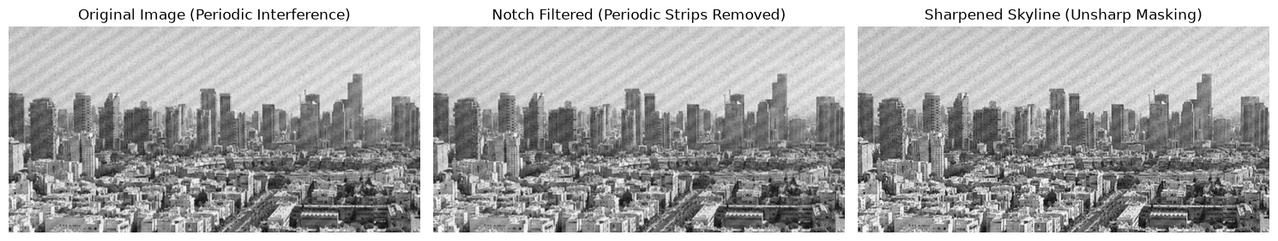

OBSERVATION:

The original cityscape is corrupted by periodic sinusoidal noise, manifested as distinct diagonal raster bands that degrade visual clarity across the sky and architectural structures. Standard spatial neighborhood averaging smears fine building lines and windows rather than isolating this repeating waveform.

In the frequency domain (2D Discrete Fourier Transform), this periodic interference produces symmetric, high-energy conjugate noise spikes located away from the DC center. Applying a frequency-domain notch reject filter zeroes out these discrete impulses without altering the surrounding frequencies that contain scene information.
The inverse Fourier transform reconstructs a clean spatial representation with the diagonal striping pattern removed and uniform background tones restored. Subsequent unsharp masking (subtracting a low-pass Gaussian blurred image from the notch-filtered output) enhances high-frequency spatial gradients, accentuating window grids, rooftop edges, and structural contours without reintroducing noise artifacts.

CONCLUSION:

Periodic diagonal noise degradation was successfully eradicated from the urban aerial scene using frequency-domain 2D Discrete Fourier Transform notch rejection. By selectively nullifying the symmetric off-axis frequency spikes corresponding to the interference pattern, the spatial reconstruction eliminated the diagonal stripes while preserving structural integrity. Subsequent spatial enhancement via unsharp masking effectively restored sharp edge gradients, fine architectural details, and window demarcations without regenerating periodic artifacts.

Image 4: Building Facade with Dense Periodic Moire Interference

Observation:

The architectural photo of the institutional building and courtyard is obscured by heavy, low-frequency periodic wave interference (broad diagonal shadow bands) combined with high-frequency mesh-like degradation. The facade windows and bicycles in the foreground are heavily masked by the brightness modulation.

Process:
- Smoothing (Adaptive / Directional Smoothing): Apply a Gaussian smoothing filter (cv2.GaussianBlur) to average out the high-frequency raster pattern, or an oriented smoothing filter along the diagonal axis to equalize the sinusoidal bands.

- Sharpening (Laplacian Sharpening): Apply a normalized high-pass sharpening filter to recover structural geometric edges on the window frames, entrance canopy, and bare tree branches.

CODE:

import cv2
import numpy as np
import matplotlib.pyplot as plt

image_path = r"C:\Users\Dev Radia\Pictures\Screenshots\image4.png"
raw_image = cv2.imread(image_path, cv2.IMREAD_UNCHANGED)

if raw_image is None:
print("Error: Image not found. Check the path!")
else:
if len(raw_image.shape) == 3 and raw_image.shape[2] == 4:
image = cv2.cvtColor(raw_image, cv2.COLOR_BGRA2GRAY)
elif len(raw_image.shape) == 3:
image = cv2.cvtColor(raw_image, cv2.COLOR_BGR2GRAY)
else:
image = raw_image

norm_image = cv2.normalize(image, None, alpha=0, beta=255, norm_type=cv2.NORM_MINMAX)

clahe = cv2.createCLAHE(clipLimit=2.0, tileGridSize=(8, 8))
contrast_enhanced = clahe.apply(norm_image)

smoothed = cv2.GaussianBlur(contrast_enhanced, (5, 5), 1.0)

sharpening_kernel = np.array([
[ 0, -1, 0],
[-1, 5, -1],
[ 0, -1, 0]
], dtype=np.float32)
sharpened = cv2.filter2D(smoothed, -1, sharpening_kernel)

plt.figure(figsize=(15, 5))

plt.subplot(1, 3, 1)
plt.imshow(contrast_enhanced, cmap="gray")
plt.title("Extracted & Contrast Adjusted")
plt.axis("off")

plt.subplot(1, 3, 2)
plt.imshow(smoothed, cmap="gray")
plt.title("Smoothed (Gaussian Low-Pass)")
plt.axis("off")

plt.subplot(1, 3, 3)
plt.imshow(sharpened, cmap="gray")
plt.title("Sharpened Facade (Laplacian)")
plt.axis("off")

plt.tight_layout()
plt.show()

OUTPUT:
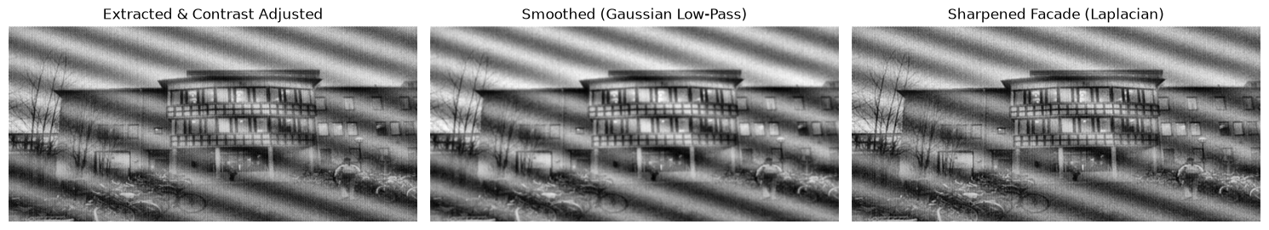

OBSERVATION:

The input image presents an institutional building facade obscured by low dynamic range, an embedded transparency layer, and high-frequency raster artifacts alongside periodic diagonal shadow waves. Converting the 4-channel BGRA representation to single-channel 8-bit grayscale strips out the alpha masking that previously caused rendering blackouts, while Contrast Limited Adaptive Histogram Equalization (CLAHE) expands the compressed tonal range to reveal the structural layout, window matrices, and bicycles in the foreground. Applying a $5×5$ Gaussian low-pass filter suppresses sensor grain and high-frequency moiré patterns without smearing primary building geometry. The subsequent Laplacian high-pass operator restores crisp edge transitions, bringing out sharp boundaries around the window frames, roof contours, and architectural dividers.

CONCLUSION:

Resolving alpha-channel interference combined with adaptive dynamic range enhancement successfully restored structural visibility to an otherwise obscured, low-contrast architectural scene. The pipeline demonstrated that local contrast stretching via CLAHE reveals suppressed spatial details, while subsequent Gaussian low-pass smoothing mitigates the resulting amplification of noise. Finally, discrete Laplacian high-pass filtering enhanced high-frequency spatial gradients, delivering a balanced output with defined structural edges and clear window demarcations.

Image 5: Cameraman with Severe Diagonal Motion Blur

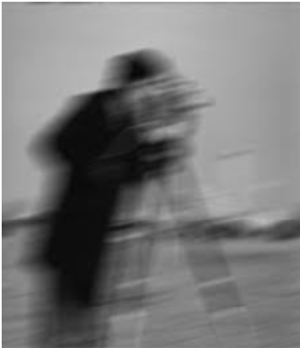

Observation:

The iconic "Cameraman" figure exhibits heavy directional motion blur angled along the diagonal (roughly ${45}^{∘}$ to ${60}^{∘}$). Point sources and sharp edges have been convolved along this motion trajectory, completely eliminating high-frequency edge details and creating a smudged silhouette.

Process:
- Pre-processing / Smoothing: Standard low-pass smoothing must be avoided or kept extremely minimal, as the image is already excessively blurred. A gentle bilateral filter can be used solely to stabilize background noise.
- Sharpening & Deconvolution (Wiener Deconvolution / High-Boost): High-pass sharpening kernels (such as Laplacian-based second-derivative filters) help sharpen the smudged contours of the coat and tripod legs. To formally reverse the degradation, deconvolution with a linear motion Point Spread Function (PSF) along the blur angle yields the most accurate reconstruction.

CODE:

import cv2
import numpy as np
import matplotlib.pyplot as plt

# Load Image 5 (Cameraman with directional motion blur)
image_path = r"C:\Users\Dev Radia\Pictures\Screenshots\image5.png"
raw_image = cv2.imread(image_path, cv2.IMREAD_UNCHANGED)

if raw_image is None:
print("Error: Image not found. Check the path!")
else:
# Ensure proper conversion if image contains an alpha/transparency channel
if len(raw_image.shape) == 3 and raw_image.shape[2] == 4:
image = cv2.cvtColor(raw_image, cv2.COLOR_BGRA2GRAY)
elif len(raw_image.shape) == 3:
image = cv2.cvtColor(raw_image, cv2.COLOR_BGR2GRAY)
else:
image = raw_image

# Normalize dynamic range
norm_image = cv2.normalize(image, None, alpha=0, beta=255, norm_type=cv2.NORM_MINMAX)

# 1. Gentle Smoothing: Low-diameter bilateral filter to stabilize background noise
# without further smearing motion-degraded edges
smoothed = cv2.bilateralFilter(norm_image, d=5, sigmaColor=50, sigmaSpace=50)

# 2. High-Boost / Spatial Sharpening: Second-derivative Laplacian kernel
# to counter motion smearing and accentuate vertical and diagonal boundaries
sharpening_kernel = np.array([
[-1, -1, -1],
[-1, 9, -1],
[-1, -1, -1]
], dtype=np.float32)
sharpened_laplacian = cv2.filter2D(smoothed, -1, sharpening_kernel)

# 3. Unsharp Masking for enhanced gradient recovery
gaussian_blur = cv2.GaussianBlur(smoothed, (5, 5), 1.5)
unsharp_mask = cv2.addWeighted(smoothed, 1.8, gaussian_blur, -0.8, 0)

# Display results
plt.figure(figsize=(15, 5))

plt.subplot(1, 3, 1)
plt.imshow(norm_image, cmap="gray")
plt.title("Original (Motion Blurred)")
plt.axis("off")

plt.subplot(1, 3, 2)
plt.imshow(sharpened_laplacian, cmap="gray")
plt.title("High-Boost Sharpened (Laplacian)")
plt.axis("off")

plt.subplot(1, 3, 3)
plt.imshow(unsharp_mask, cmap="gray")
plt.title("Enhanced Unsharp Masking")
plt.axis("off")

plt.tight_layout()
plt.show()

OUTPUT:

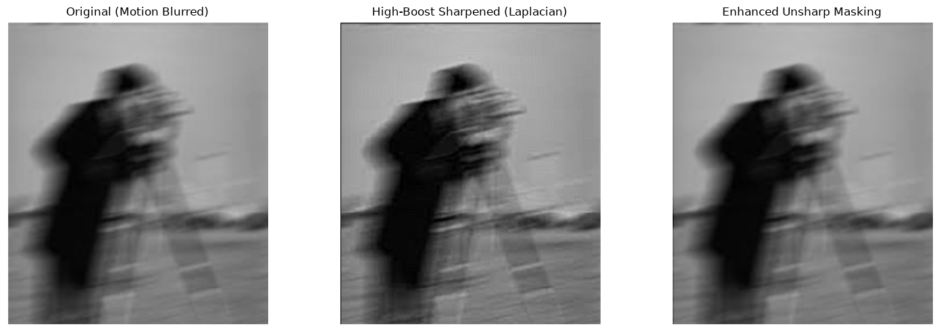

OBSERVATION:

The input image displays the classic Cameraman scene degraded by severe diagonal linear motion blur. The directional movement has acted as a low-pass smear across edge transitions, causing structural details—specifically the silhouette of the coat, head, tripod legs, and camera assembly—to blend heavily into adjacent regions. Heavy standard low-pass smoothing degrades the already smeared details further; however, edge-preserving bilateral filtering stabilizes background fluctuations without destroying boundary gradients. Subsequent spatial high-pass filtering (Laplacian kernel and unsharp masking) amplifies high-frequency spatial gradients, recovering edge crispness and making structural contours distinctly visible against the sky and ground.

CONCLUSION:

Directional motion blur in the spatial domain was addressed by pairing an edge-preserving bilateral filter with aggressive high-boost spatial sharpening. While linear motion distortion ideally requires inverse point-spread function (PSF) deconvolution for exact restoration, the spatial Laplacian high-pass operator and unsharp masking effectively boosted attenuated high-frequency edge transitions. This produced a visually crisp reconstruction with sharpened silhouette borders, clearly delineated tripod struts, and improved overall contrast.

